**Pros and Cons of NoSQL Database for Vector Search:**

**NoSQL** databases, such as **MongoDB** and Cassandra, are becoming increasingly popular for use in vector search applications, especially in fields like machine learning and AI. Vector search is critical for tasks such as recommendation systems, natural language processing, and image retrieval, where data is represented as high-dimensional vectors. Let’s explore the **pros** and **cons** of using **NoSQL** databases for vector search with a real-world example.

* **Pros of NoSQL for Vector Search:**

1. **Scalability:** NoSQL databases are inherently designed to scale horizontally, which means they can handle large datasets and distribute them across many servers. This is crucial for vector search applications that require quick retrieval from massive datasets.

* **Example:** Suppose you're building an e-commerce recommendation engine that stores millions of product embeddings (vector representations). A NoSQL database like MongoDB can scale horizontally to support fast retrieval across large clusters of data.

1. **Flexibility in Data Models:** NoSQL databases support unstructured and semi-structured data, which is often the case in machine learning applications. They can store not only vector representations but also associated metadata in flexible document structures.

* **Example:** In a recommendation system, you may store user behaviour as metadata alongside the vector embeddings, allowing more personalized and context-aware vector search.

1. **Low Latency Retrieval:** With efficient indexing and sharding, NoSQL databases can deliver low-latency retrieval for vector search, making them suitable for real-time applications.

* **Example:** A chatbot application might use vector search to match user queries to relevant responses in real-time, requiring near-instantaneous retrieval.

1. **Distributed and Fault-Tolerant:** Most NoSQL databases are distributed and come with built-in fault tolerance. This ensures that even in the event of hardware failures, the vector search can continue without significant downtime.

* **Example:** In a large-scale ML platform using vector search for recommendation, NoSQL can ensure high availability even if a node in the cluster goes down.
* **Cons of NoSQL for Vector Search:**

1. **Limited Nativ Support for Vector Operations:** NoSQL databases were not originally designed for vector search. While they can store vectors, they often lack specialized algorithms (like approximate nearest neighbour search, ANN) that are critical for efficient vector search in high-dimensional space.

* **Example:** If you're using MongoDB to store embeddings of product reviews, running a k-nearest neighbours (k-NN) query might require additional layers of application logic or external libraries, which increases complexity and slows down performance.

1. **Query Performance at Scale:** NoSQL databases may struggle with performance at a large scale if the database doesn't have built-in support for high-dimensional search. Running vector similarity queries can become inefficient as datasets grow larger, especially when specialized indexing techniques like HNSW or FAISS are absent.

* **Example:** An image search engine that uses millions of image embeddings might face slowdowns when using NoSQL for vector search, as performing cosine similarity calculations on such large datasets requires heavy computation.

1. **Lack of Specialized Indexing:** Unlike vector search engines like Pinecone, Milvus, or FAISS, most NoSQL databases do not support highly optimized vector search indexing techniques. Instead, they rely on traditional indexing methods, which can limit performance for high-dimensional vectors.

* **Example:** If you’re building a real-time facial recognition system, using NoSQL for vector search would lead to slower retrieval compared to a dedicated vector search solution, because NoSQL databases often lack optimized tree or graph-based indexes for vector.

1. **Complexity in Integration:** NoSQL databases don’t natively support vector search, so integrating an efficient vector search mechanism often requires additional development, such as using external libraries or a separate vector search service. This adds architectural complexity and maintenance overhead.

* **Example:** If you're building a personalized search engine, you may need to integrate MongoDB with a separate ANN engine (like FAISS), complicating the data pipeline and increasing system complexity.

**Why Use NoSQL and Vector Database in Generative AI Projects?**

1. **Handling Unstructured and Semi-Structured Data:**

* Generative AI models often deal with various types of data, such as text, images, audio, and even unstructured data. NoSQL databases, like MongoDB or Cassandra, are ideal for storing this data as they support flexible schema structures.
* For instance, language models trained on textual data may need to access both structured information (like user profiles) and unstructured content (like user-generated text). NoSQL databases can seamlessly handle this mix.

1. **Efficient Similarity Search:**

* Many generative AI applications (e.g., text generation, image generation) require efficient similarity searches. Vector databases are purpose-built to handle high-dimensional vector embeddings, which are often the result of deep learning models.
* For instance, in a generative AI-based recommendation system, embeddings for users and items are stored in a vector database, allowing the system to quickly find similar vectors and generate personalized recommendations.

1. **Support for Real-Time and Low-Latency Application:**

* NoSQL databases offer low-latency access to large datasets, which is crucial for real-time generative AI applications like chatbots, recommendation engines, and image generation systems.
* Vector databases, with optimized nearest-neighbor search algorithms (such as Approximate Nearest Neighbors), provide fast query responses for applications that require quick similarity matching.

**How People Use NoSQL and Vector Databases in Generative AI Projects:**

* **NoSQL Database Usages:**
* **Storage of Training and Metadata:** NoSQL databases, like MongoDB, store metadata about the training data, such as user profiles, documents, and interaction histories. These databases also serve as repositories for storing fine-tuned model parameters, user data, and other non-relational datasets.
  + **Example:** In a chatbot application, MongoDB stores user conversations, interactions, and preferences in flexible JSON-like documents. The generative AI model can then use this data to generate responses based on past conversations.
* **Data processing:** In AI workflows, NoSQL databases are often used for pre-processing data before it's fed into the model. Unstructured or semi-structured data, like social media posts or news articles, can be stored and then transformed into structured formats for model training.
  + **Example:** In a text generation model, you may scrape web articles or social media data and store them in MongoDB, where the data can be cleaned and pre-processed before being fed into the model for fine-tuning.
* **Vector Database Usages:**
* **Efficient Retrieval of Embeddings:** Vector databases are used to store and retrieve vector embeddings generated by AI models. These embeddings are high-dimensional representations of data (e.g., text, images) and are used for similarity searches.
* **Example:** In an AI-powered image generator, vector databases like Milvus store image embeddings. When a user uploads a sketch or partial image, the system retrieves similar images from the database based on their vector representation, helping the generative model create a new image.
* **Similarity Search for Generative AI:** Vector databases enable fast similarity searches by efficiently finding vectors that are close to each other in high-dimensional space. This is crucial in generative AI applications where matching embeddings is key for generating content (e.g., finding similar texts, images, or user preferences).
* **Example:** In a recommendation engine powered by a generative AI model, vector embeddings of user preferences and product attributes are stored in a vector database. When a user requests a recommendation, the system retrieves the nearest product vectors, and the AI model generates a list of personalized recommendations.

**Benefits of Using NoSQL and Vector Databases in Generative AI Projects:**

1. **Scalable Data Storage:**

* NoSQL databases handle massive, complex datasets without strict schema requirements, making them ideal for AI applications where data formats evolve frequently.
* Vector databases are optimized to store embeddings at scale, providing efficient querying and retrieval capabilities.

1. **Real-Time Data Processing:**

* NoSQL databases offer fast access to diverse datasets, supporting real-time generative AI applications like chatbots or image generation.
* Vector databases support low-latency similarity searches, which is essential for applications like recommendation systems and conversational AI.

1. **Efficient Vector Search:**

* Vector databases handle the complexity of high-dimensional vector search (e.g., nearest neighbor search), enabling faster and more accurate retrieval of data points for generative tasks like text generation, image synthesis, and voice cloning.

1. **Flexibility:**

* The flexibility of NoSQL databases allows for easy storage and manipulation of heterogeneous data types (e.g., text, images, audio), which is critical for multimodal AI applications.
* Vector databases are highly specialized for vector retrieval, allowing for seamless integration with deep learning models that generate embeddings.

Using **NoSQL** databases for storing diverse and large datasets, along with **Vector** databases for efficient similarity searches, enhances the performance, scalability, and flexibility of generative AI applications. These technologies enable real-time data handling, seamless integration of multimodal data, and efficient retrieval of relevant information for tasks like content generation, personalization, and recommendation.

**Pinecone Vector Database:**

**Pinecone** is a specialized **vector database** designed to store, manage, and query vector embeddings. It is built specifically for **high-dimensional vector search** and enables applications like **semantic search**, **recommendation systems**, **question-answering**, and **image retrieval**, where traditional databases struggle to perform efficiently.

Vectors are numerical representations of data (e.g., text, images, audio) that encode the semantics of the information in high-dimensional space. **Pinecone** provides an infrastructure for managing these vectors, allowing users to quickly perform **similarity searches**, **nearest-neighbor lookups**, and other vector-based queries.

* **Key features of Pinecone:**
* **Efficiency Vector Storage and Retrieval:** Pinecone is optimized for storing large volumes of high-dimensional vectors and performing efficient nearest-neighbor searches on them. It uses advanced indexing algorithms like **Approximate Nearest Neighbor (ANN)** search techniques (e.g., **HNSW**).
* **Scalability:** It can handle billions of vectors, enabling large-scale applications. Pinecone's infrastructure allows for easy scaling without the complexities of managing distributed databases.
* **Real-Time Search Capabilities:** Pinecone supports **low-latency vector search**, allowing for real-time applications such as **interactive chatbots** or **dynamic content recommendations.**
* **Indexing and Filtering:** Pinecone offers customizable vector indexing and filtering capabilities, enabling users to perform conditional searches, such as finding vectors that are similar while meeting certain conditions (e.g., vectors associated with a particular category).
* **Integration with ML Workflows:** It integrates seamlessly with machine learning workflows by allowing easy ingestion of embeddings generated by models like **BERT**, **GPT**, **ResNet**, etc. These embeddings can be indexed, searched, and managed using Pinecone.
* **How Pinecone Works: Step-by-Step Process**

1. **Vector Generation:** Machine learning models (e.g., language models like **BERT** or **image models** like **ResNet**) generate embeddings (vectors) from input data such as text, images, or audio.
2. **Indexing in Pinecone:** These vectors are indexed in Pinecone, which organizes them using an internal data structure optimized for efficient similarity search. The database uses **ANN algorithms** to index the vectors in a way that supports fast retrieval.
3. **Querying:** When a query vector is provided, Pinecone performs a similarity search to find the **nearest neighbors** (vectors that are most similar to the query). This is typically done using distance metrics such as **cosine similarity** or **Euclidean distance.**
4. **Result Filtering:** Pinecone allows for filtering based on metadata associated with vectors. For example, you can search for vectors with specific tags or within certain ranges.
5. **Real-Time Updates and management:** Vectors can be added, updated, or deleted in real-time, ensuring that the search results remain relevant.

* **Example use Cases: Semantic Search**

Let’s look at how Pinecone can be used for a **semantic search application.**

**Scenario**: Building a Document Search Engine.

Suppose you have a collection of articles, and you want to create a search engine where users can find relevant articles based on the meaning of their search queries, not just keyword matching.

**Step-by-Step Workflow:**

1. **Text Data Preparation:** You have a dataset of articles, and each article consists of multiple paragraphs.
2. **Embedding Generation:** Use a pre-trained **language model** (e.g., **BERT**, **Sentence Transformers**) to generate **vector embeddings** for each paragraph in the articles. These embeddings represent the **semantic meaning** of the text.
3. **Indexing in Pinecone:** Push these embeddings into a **Pinecone index**, where they are stored as vectors. You can also associate metadata with each vector, such as the article title, publication date, or paragraph ID.
4. **User Query Handling:** When a user performs a search query, convert the query into a vector embedding using the same language model.
5. **Querying Pinecone for Similarity Search:** Use Pinecone to find the most **similar vectors** to the query vector. This search retrieves the paragraphs that are semantically closest to the user's input.
6. **Filtering and Ranking:** Optionally, apply **filters** to limit the results based on metadata (e.g., only search within certain categories). Pinecone ranks the results based on similarity scores.
7. **Presenting the Results:** Display the retrieved articles or paragraphs to the user in a ranked list.

* **Technical Details Behind the Pinecone:**

1. **Indexing Techniques:** Pinecone uses **ANN (Approximate Nearest Neighbor)** search techniques, such as **HNSW (Hierarchical Navigable Small World)**, to quickly find vectors that are close to the query vector.
2. **Distance Metrics:** Common metrics used include **cosine similarity**, **Euclidean distance**, and **dot product**. These metrics measure how "close" vectors are in the high-dimensional space.

* **Cosine Similarity:**

**Cosine similarity** measures the **cosine of the angle** between two non-zero vectors in a high-dimensional space. It is a measure of the **directional similarity** between vectors, regardless of their magnitudes. The resulting similarity value ranges from **-1** to **1**:

* **1** means the vectors are identical in direction.
* **0** means the vectors are orthogonal (no similarity).
* **-1** means the vectors are diametrically opposite in direction.

**Formula:**

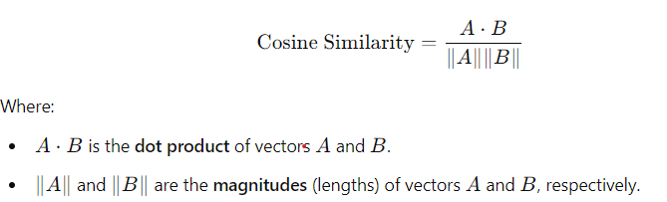

**Use Case:**

Cosine similarity is often used in **text analysis** (e.g., comparing the similarity of documents) because it captures the similarity in the direction of word embeddings without being affected by the length of the documents.

**Example:**

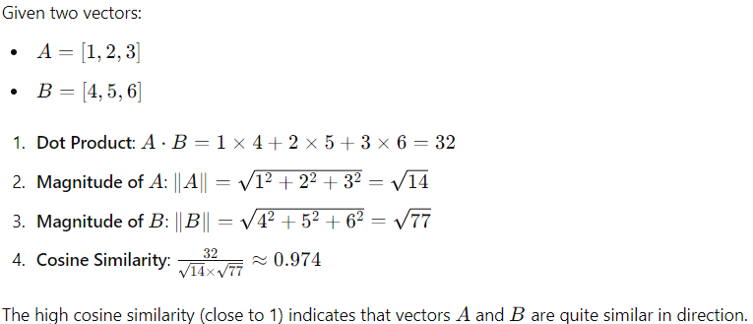

* **Euclidean Distance:**

**Euclidean distance** is a measure of the **straight-line distance** between two points in a multi-dimensional space. It quantifies the magnitude of the difference between the two vectors. **The smaller the distance, the more similar the vectors are**.

**Formula:**

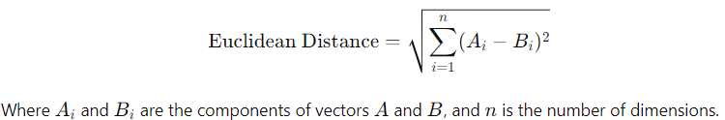

**Use Case:**

Euclidean distance is often used in **clustering algorithms** (e.g., **K-means**) and **nearest-neighbor search** to measure how far apart data points are in a feature space.

**Example:**

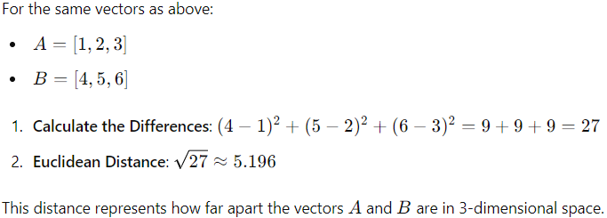

* **Dot Product:**

The **dot product** (or **inner product**) of two vectors measures the extent to which the vectors point in the **same direction**. It is the sum of the products of the corresponding components of the vectors.

**Formula:**

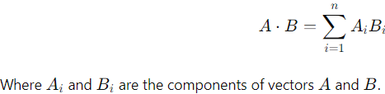

**Use case:**

The dot product is commonly used in **machine learning** and **vector mathematics** to project one vector onto another and to compute **cosine similarity**. It also helps in understanding whether two vectors are **aligned** or **perpendicular** (if the dot product is zero).

**Example:**

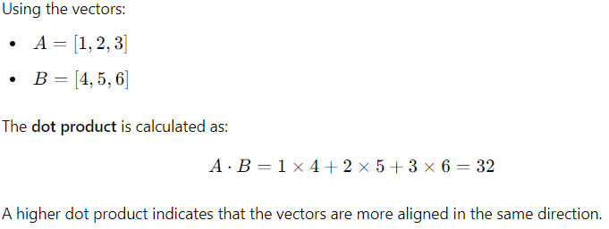

1. **Scaling Capabilities:** Pinecone automatically manages **sharding** and **replication** across servers, making it highly scalable for large datasets.
2. **Filtering Capabilities:** Pinecone supports metadata-based filtering; allowing searches to be constrained by various conditions (e.g., time range, document type).

* **Indexing Algorithms:**

1. **ANN (Approximate Nearest Neighbor):**

**Approximate Nearest Neighbor (ANN)** algorithms aim to efficiently find the nearest neighbors of a given query point in a high-dimensional space. Unlike **exact nearest neighbor** search, which guarantees finding the closest points with 100% accuracy, ANN algorithms trade off some accuracy for **faster search times** and **lower computational costs**. This makes ANN techniques suitable for large-scale and high-dimensional data where exact search is computationally infeasible.

**Why Use ANN?**

* **High-dimensional data:** In high dimensions, exact nearest neighbor search becomes computationally expensive due to the "**curse of dimensionality**." The time complexity increases significantly as the number of dimensions grows.
* **Large datasets:** For datasets containing millions or billions of points, exact search is time-consuming. ANN algorithms provide a way to find neighbors quickly with acceptable accuracy.

**How ANN Works: General Approach**

1. **Data Structure Creation:** ANN algorithms pre-process the data to create an **index** (e.g., trees, graphs, hash tables) that allows for efficient querying.
2. **Querying:** Given a query point, the algorithm uses the index to find a set of candidate neighbors, which are then evaluated to approximate the nearest neighbors.
3. **Result Refinement:** Depending on the method used, the algorithm may further refine the results to improve accuracy. However, the goal is not to guarantee finding the exact nearest neighbor but to provide a good approximation.

**Common ANN Algorithms:**

* **LSH (Locality-Sensitive Hashing):** Hashes input data so that similar points are mapped to the same bucket with high probability.
* **HNSW (Hierarchical Navigable Small World):** A graph-based approach that uses a hierarchical structure to find nearest neighbors efficiently.

1. **HNSW (Hierarchical Navigate Small World):**
2. **LSH (Locality-Sensitive Hashing):**

* **Pinecone References Docs (Important Insights):**

1. **Indexes:**

In Pinecone, an **index** is the primary structure where vector data is stored, managed, and queried. Each index organizes vectors and provides mechanisms for **nearest neighbor search**, allowing efficient retrieval of similar vectors based on similarity metrics (e.g., cosine similarity, Euclidean distance, dot product).

**Key Characteristics Indexes:**

* **Vector Storage:** Indexes store vectors along with optional metadata (tags, identifiers) associated with each vector.
* **Index Types:** Pinecone supports different types of indexes optimized for various retrieval methods, including **Approximate Nearest Neighbor (ANN)** techniques.
* **Similarity Metrics:** When creating an index, you specify the metric (e.g., **cosine similarity**, **Euclidean distance**) used to measure vector similarity.

**Example Usage:**

In a semantic search application, an index might be used to store document embeddings. When a query is provided, the index retrieves the most similar document vectors based on cosine similarity.

1. **Pods:**

**Pods** in Pinecone refer to the **compute units** that provide the processing power and storage capacity for an index. Each pod consists of resources (CPU, memory, storage) that manage the data operations, such as vector insertion, indexing, and querying.

**Key Characteristics of Pods in Pinecone:**

* **Scaling:** Pods can be scaled horizontally to accommodate larger datasets or to improve query throughput. Multiple pods allow for distributed storage and processing.
* **Replication:** You can increase the number of replicas for fault tolerance and to handle higher read workloads.
* **Pod Size Variants:** Different pod size options are available (e.g., **s1**, **s2**, etc.), where larger pod sizes provide more computational resources and storage capacity.

**Example Usage:**

A small application with a few thousand vectors may use a single pod. For a large-scale recommendation system handling billions of vectors, multiple pods with replication might be used.

1. **Serverless:**

**Serverless** in Pinecone refers to the platform's ability to **automatically manage infrastructure**, allowing developers to focus on building applications without worrying about scaling, provisioning, or maintaining servers.

**Key Characteristics of Serverless in Pinecone:**

* **Automatic Scaling:** The platform scales compute resources up or down based on the workload. This ensures efficient resource usage and cost management.
* **No Manual Infrastructure Management:** Users don't have to manually provision or manage servers; Pinecone takes care of the underlying infrastructure.
* **Pay-per-Use:** Costs are based on the actual usage, such as the number of queries or the amount of data stored, making it cost-effective for various workloads.

**Example Usage:**

For an application with unpredictable traffic patterns (e.g., seasonal e-commerce), Serverless architecture can automatically adjust resources to meet the demand during peak hours and reduce costs during off-peak times.

1. **Various Data Operations:**

Pinecone supports a variety of **data operations** that allow you to manage vector data in an index. These operations include:

* **Inserting Vectors:** 
  + Add new vectors to the index along with any associated metadata.
  + Supports batch inserts to optimize the performance when dealing with large datasets.
* **Updating Vectors:** 
  + Modify existing vectors by updating their values or associated metadata.
  + Useful for applications where data is continually evolving (e.g., user preferences in a recommendation system).
* **Deleting Vectors:** 
  + Remove vectors from the index when they are no longer needed.
  + Can also be used to delete specific metadata fields without removing the entire vector.
* **Querying Vectors:** 
  + Perform similarity search to find vectors that are closest to a given query vector.
  + Supports filtering by metadata, allowing for conditional queries (e.g., search within specific categories).

1. **Inference:**

**Inference** in Pinecone typically involves using **pre-trained models** to convert raw data (text, images, audio) into **vector embeddings**. These embeddings are then stored in Pinecone for efficient querying.

**Steps for Inference with Pinecone:**

* **Data Preparation:** Use machine learning models (e.g., **BERT** for text, **ResNet** for images) to generate vector embeddings from raw input.
* **Vector Storage:** Insert these embeddings into a Pinecone index.
* **Query and Search:** When a new input is provided, generate its embedding and use Pinecone to find the nearest neighbors from the stored vectors.

**Example:**

In a chatbot, user queries are converted into vector embeddings using a language model. Pinecone retrieves the most relevant responses from a database of stored embeddings.

1. **Assistance:**

**Advanced Retrievers:**

* **Contextual Compressor Retriever:**

The **Contextual Compressor Retriever** is a retrieval technique designed to improve information retrieval by focusing on the most relevant parts of documents based on the user's query. It aims to reduce the size of the retrieved information by compressing the context, thereby retaining only the most important content. This technique enhances the quality of responses and makes it easier for models to work with limited context windows (e.g., when generating responses).

* **How Contextual Compressor Retriever Works:**

1. **Basic Retrieval:** The process begins with a standard retrieval step, where the initial set of documents or passages relevant to the user's query is retrieved. This could be done using methods like **BM25**, **Dense Vector Retrieval**, or **Hybrid Retrieval.**
2. **Contextual Compression:** After the initial retrieval, a **compression step** is applied. The retrieved documents are further analysed to identify and retain only the most relevant parts of the documents based on the original query.

* The compression can be done using techniques like:
  + **Extractive summarization**: Selecting key sentences or paragraphs.
  + **Query-focused summarization**: Compressing the document by focusing on content directly related to the query.

1. **Refined Retrieval with Compressed Context:** The compressed documents are then used to perform a more focused retrieval step, ensuring that the most relevant information is considered in subsequent processes, such as answer generation.
2. **Final Output:** The results from the refined retrieval are presented as the final output, providing concise and contextually rich information.

* **Example of Contextual Compressor Retriever:**

**User Query:** “What are the benefits of multi-head attention in Transformers?”

**Step-by-Step Process:**

1. **Initial Retrieval:** Suppose the query retrieves several documents related to “**multi-head attention**” and “**Transformer models**.” Each document may contain multiple sections discussing various aspects, such as the architecture, different types of attention, and training techniques.
2. **Contextual Compression:** The retriever then compresses each document to keep only the parts that are most relevant to the benefits of multi-head attention. For example:

* A passage discussing how multi-head attention allows for parallel processing and captures different patterns in data might be kept.
* Irrelevant sections, such as implementation details or other types of attention mechanisms, are discarded.

1. **Refined Retrieval with Compressed Documents:** The compressed documents (containing only the relevant sections) are used to conduct a second round of retrieval, refining the results to ensure they directly address the original query.
2. **Final Output:** The final retrieved documents contain concise, focused information about the benefits of multi-head attention, such as its ability to capture various relationships in the data and enhance model performance.

* **Benefits of Contextual Compressor Retriever:**
* **Reduces Irrelevant Information:** By compressing documents to focus on relevant content, the technique ensures that the retrieved results are concise and useful.
* **Handles Long Documents Better:** For very long documents, retrieving and compressing the most relevant sections makes it easier to work within limited context windows (e.g., models with limited token input).
* **Improved Retrieval Accuracy:** The double-layered retrieval (initial and refined with compressed content) enhances accuracy by filtering out unnecessary details and focusing on the core information.
* **Self-Query Retriever:**

A **Self-Query Retriever** is an advanced mechanism used in **Retrieval-Augmented Generation (RAG)** to improve the retrieval process by generating better and more contextually relevant queries. It transforms the original input query into a more refined or structured set of sub-queries or expansions. These refined queries are then used to search the knowledge base, ensuring more accurate retrieval of relevant documents or passages. **“**Self-Query retriever is works when you have metadata information in your knowledgebase or vector database**”**.

Query

Attribute or metadata information

LLM

Prompts

Generate Structure Schema

Here we collect different keywords, filters, etc. This is also called Structure Query.

Most Relevant Docs

Vector DB

Prompts

LLM

**Generalized Responses**

**Example: How Self Query Retriever Works:**

**Scenario:**

* **Input Query:** “How does Transformer models work?”

**Step-by-Step Process:**

1. **Original Query:** The user's input query is “How does Transformer models work?”
2. **Generating Refined Sub-Queries:** The Self-Query Retriever generates several sub-queries:

* **“**What is self-attention in Transformer models?**”**
* **“**What role does positional encoding play in Transformers?**”**
* **“**How do Transformer models differ from LSTM models?**”**

1. **Retrieving Relevant Documents:** Each of the sub-queries is used to search the knowledge base, retrieving documents that cover these specific aspects of Transformer models.
2. **Combining the Results:** The relevant information retrieved from the various sub-queries is **combined and synthesized** to provide a comprehensive answer to the original query.
3. **Final Response:** The system generates a final answer by integrating information about self-attention, positional encoding, and comparisons to other models, providing a detailed explanation of how Transformer models work.

**When to Use Self Query Retrieve:**

A Self-Query Retriever is particularly useful in scenarios where:

1. **Complex or Ambiguous Queries:** The original query is either too broad or lacks specificity. The Self-Query Retriever can break down the query into more specific sub-queries.
2. **Multi-Faced Information Needs:** The user’s question may contain **multiple aspects or dimensions** that need to be addressed separately. For example, a question like "What are the advantages of multi-head attention in Transformers?" may involve aspects such as computational efficiency, interpretability, and modelling power.
3. **Improving Recall and Precision in Retrieval:** When traditional keyword-based searches fail to capture the context or meaning of the query, refined sub-queries generated by a Self-Query Retriever can enhance the retrieval process by targeting different angles of the question.

**Problems with Basic RAG Workflow:**

In a basic RAG workflow, there are some challenges that the Self-Query Retriever can help overcome:

1. **Poor Query Representation:**

* In a standard RAG setup, the original input query is used directly to search the knowledge base. If the query is ambiguous, incomplete, or too broad, the retrieval may not find the most relevant documents.
* **Solution:** The Self-Query Retriever generates refined sub-queries that are more targeted and align better with the knowledge base.

1. **Handling Complex or Multi-Part Queries:**

* Basic RAG workflows may struggle to handle queries that require multiple pieces of information or cover different subtopics. For **example**, "Explain how transformers and LSTMs differ in handling sequential data."
* **Solution:** The Self-Query Retriever can break the query into multiple sub-queries, addressing each aspect separately, thus improving the completeness of the response.

1. **Limited Recall:**

* In a basic RAG workflow, if the original query does not match well with the content in the knowledge base, relevant documents may be missed.
* **Solution:** By using multiple refined sub-queries, the Self-Query Retriever increases the chances of retrieving relevant documents, thereby improving recall.

1. **Unstructured Queries:**

* Basic RAG may struggle with queries that are not well-structured or follow natural language conventions, leading to poor retrieval.
* **Solution:** The Self-Query Retriever converts such queries into more structured sub-queries, making it easier for the system to retrieve relevant information.
* **Parent Document Retriever:**

The **Parent Document Retriever** is a retrieval strategy used in **information retrieval** and **RAG (Retrieval-Augmented Generation)** workflows. It aims to improve the quality of retrieved information by leveraging the relationship between **smaller document chunks (children)** and their **larger parent documents**. This method ensures that the context of the information is preserved and provides more comprehensive answers to user queries.

Parent 1

Parent 2

Parent 3

Child p11

Child p12

Child p21

Child p22

Child p31

Child p32

Documents

**How Parent Document Retrieval Works:**

The Parent Document Retriever works by first retrieving relevant child documents (smaller chunks of text) and then identifying their corresponding parent documents (the larger documents from which the chunks were derived). This process helps maintain the original context and provides richer information.

**Steps-by-Steps Workflow of the Parent Document Retriever:**

1. **Data Preparation and Chunking:** The original documents (parent documents) are divided into smaller **chunks** or **sections** (child documents) for indexing. For example, a research paper could be broken down into sections or paragraphs.
2. **Indexing the Child Documents:** The smaller chunks (child documents) are indexed in a **vector database**, allowing them to be retrieved based on their semantic similarity to a given query.
3. **Query Processing and Initial Retrieval:** When a user submits a query, the retrieval process starts by finding the top-ranked child documents (chunks) that are most similar to the query using similarity metrics such as cosine similarity or Euclidean distance.
4. **Mapping to Parent Documents:** Once the relevant child documents are retrieved, the **Parent Document Retriever** maps these child documents to their **corresponding parent documents**. This involves identifying the larger original documents that contain the retrieved chunks.
5. **Combining the Results and Ranking Parent Documents:** The retrieved parent documents are aggregated and ranked based on the relevance of the child documents retrieved. This ensures that the most relevant parent documents are presented to the user.
6. **Final Output:** The system returns the parent documents (or sections of the parent documents) as the final retrieval result, providing a more complete and contextually accurate response.

**Advantages Parent Document Retrieval:**

1. **Maintains Context:** By mapping child documents back to their parent documents, the approach ensures that the retrieved information retains its original context, leading to more accurate and comprehensive responses.
2. **Improved Retrieval Accuracy:** Parent Document Retrieval reduces the chances of providing isolated or out-of-context information by aggregating related content from the same source.
3. **Better Coverage of Multi-Part Queries:** When a query requires multiple pieces of information, this approach ensures that various relevant sections from the same parent document can be retrieved together.

**When to Use Parent Document Retrieval:**

* **Long Documents or Structured Content:** It is beneficial when dealing with long documents (e.g., books, research papers, manuals) that are broken down into smaller sections. Parent Document Retrieval ensures the relevant sections are tied back to the full document.
* **Preserving Context:** It is useful when the context of the information is important, such as legal documents or technical reports, where individual sections may not make sense without the larger context.
* **Multi-Step Information Retrieval:** Suitable for use cases where the retrieval needs to be refined from coarse-grained (parent level) to fine-grained (child level), or vice versa.
* **Sentence Window Retriever:**

**Sentence Window Retrieval** is a retrieval technique used to enhance the information extraction process by considering not just a single sentence but also a specified number of **surrounding sentences** (context) around it. The main idea is to improve the quality of retrieval by capturing the broader context in which a sentence appears.

* **How Sentence Window Retrieval Works:**

1. **Data Preparation:** A text document is divided into individual sentences.
2. **Window Size Definition:** The **window size** is defined (e.g., **window=3**) which specifies how many surrounding sentences (both before and after the target sentence) should be considered together as a single unit for retrieval.
3. **Creating Sentence Windows:**

* For each sentence in the document, a **“window”** is formed by taking the sentence itself and a number of surrounding sentences (before and after) based on the window size.
* These sentence windows become the basic units used for retrieval.

1. **Indexing Sentence Windows:** The sentence windows are indexed in a vector database or search engine. This allows for efficient similarity search when performing retrieval.
2. **Query Processing and Retrieval:**

* When a query is issued, it is matched against the indexed sentence windows.
* The model retrieves the most relevant sentence windows based on the similarity of the query to the combined context in each window.
* **Example of Sentence Window retrieval:**

Suppose we have the following text divided into sentences:

1. **Sentence 1: “**Transformers are powerful models for NLP.**”**
2. **Sentence 2: “**They use self-attention mechanisms.**”**
3. **Sentence 3: “**The architecture allows for parallel processing.**”**
4. **Sentence 4: “**Training requires large amounts of data.**”**
5. **Sentence 5: “**Fine-tuning improves the model's performance.**”**

**Window=3 Examples:**

* **Window Size:** Window=3 means that for each sentence, we take the target sentence plus **one preceding and one following sentence.**
* **Creating Sentence Windows:** 
  + **For Sentence 2 (**“They use Self-Attention mechanisms.”**):**
    - The surrounding context would include **Sentence 1**, **Sentence 2**, and **Sentence 3:**
      * **Combined Window: “**Transformers are powerful models for NLP. They use self-attention mechanisms. The architecture allows for parallel processing.**”**
  + **For Sentence 3 (**“The architecture allows for parallel processing.”**)**
    - The surrounding context would include **Sentence 2**, **Sentence 3**, and **Sentence 4:**
      * **Combined Window: “**They use self-attention mechanisms. The architecture allows for parallel processing. Training requires large amounts of data.**”**

In this example, each window combines three sentences to form a richer context, providing better retrieval results than using individual sentences alone.

* **Surrounding Context:**

The **surrounding context** refers to the **additional sentences** included around the target sentence when forming a sentence window. This context helps to capture more information about the topic and maintains the continuity of the narrative, making the retrieval more accurate and meaningful.

* **Benefits of Sentence Window Retrieval:**

1. **Improved Contextual Understanding:** By including surrounding sentences, the model can better understand the context and retrieve more relevant information.
2. **Enhanced Retrieval Accuracy:** It reduces the chance of retrieving isolated sentences that lack meaningful context.
3. **Suitable for Complex Queries:** When a query requires detailed understanding or involves multiple aspects, using sentence windows helps provide more comprehensive responses.

**Sentence Window Retrieval** enhances traditional sentence-level retrieval by incorporating surrounding context to form a "window" of sentences. The **window size** determines how many neighbouring sentences are included, and this technique is especially useful when trying to capture broader contextual information to improve the accuracy and quality of retrieval results. For **“window=3”** the model uses the target sentence plus one preceding and one following sentence, creating a three-sentence window for better context.

* **Hypothetical Document Embedding (HYDE):**

**Hypothetical Document Embedding (HYDE)** is a technique used in information retrieval to improve the quality of query-based document retrieval. Instead of relying solely on a given query to perform a search, HYDE generates **hypothetical documents** based on the query. These documents are then used as **proxy queries** to find relevant documents in the database. By doing so, HYDE can help retrieve more contextually relevant results.

* **How HYDE Works:**

1. **Initial Query Processing:** Start with a user-provided query. For example, let's say the query is: **“What are the benefits of multi-head attention in Transformers?”**
2. **Generating Hypothetical Documents:**

* Use a language model (such as GPT-3 or BERT) to generate a **hypothetical document** or passage based on the input query. This document serves as a possible answer or elaboration related to the query.
* For the example query, a hypothetical document could be: **“Multi-head attention allows Transformers to jointly attend to information from different representation subspaces at different positions. This enhances the model's ability to capture more nuanced relationships in the data.”**

1. **Embedding the Hypothetical Documents:** The generated hypothetical document is embedded into a vector space using a pre-trained embedding model (such as BERT embeddings or Sentence Transformers).
2. **Retrieval using the Embedded Hypothetical Document:** The hypothetical document embedding is used as a **proxy query** to search the vector database. This helps retrieve documents that are contextually similar to the hypothetical document, thereby addressing the original query.
3. **Combining Results:** The documents retrieved using the hypothetical document embeddings are presented as the final results.

* **Advantages of HYDE:**
* **Enhances Retrieval Quality:** By generating a hypothetical document, HYDE provides more contexts to the search process, improving the relevance of the retrieved results.
* **Reduces Ambiguity:** The technique helps in addressing ambiguous queries by generating a more detailed hypothetical representation of the user's intent.
* **Suitable for Complex Queries:** HYDE works well when dealing with complex or broad queries, where direct retrieval using the original query may not be effective.
* **Auto Merger Retriever:**

The **Auto Merger Retriever** is an approach used in information retrieval to **combine multiple retrieval strategies** and merge their results to improve the overall quality of retrieval. The idea is to use different retrieval techniques or configurations to obtain candidate documents and then **automatically merge** these results to get a final ranked list.

* **How Auto Merger Retriever Works:**

1. **Multiple Retriever Methods:**

* The Auto Merger Retriever employs several different retrieval methods or configurations. For example, it might use:
  + **BM25:** A traditional keyword-based retrieval method.
  + **Dense Vector Retriever:** Using embeddings to retrieve documents based on semantic similarity.
  + **Hybrid Retrieval:** Combining both sparse (BM25) and dense vector retrieval.

1. **Candidate Document Retrieval:** Each retrieval method produces its own set of candidate documents based on the given query. The same query is run through all the configured retrieval techniques, resulting in multiple ranked lists of documents.
2. **Merging the Results:** The results from all the different retrieval methods are **automatically merged** using a merging strategy. This could involve:

* **Combining the ranks** of documents from each list.
* **Weighted voting** based on the confidence score from each retrieval method.
* **Learning-to-rank** techniques to adjust the merged ranking based on training data.

1. **Final Ranked List Presentation:** The merged list is then presented as the final set of retrieved documents.

* **Example of Auto Merger Retriever:**

**User Query:** “What are the applications of Transformer models in NLP?”

**Step-by-Step Process:**

1. **Using Multiple Retrieval Methods:**

* **BM25 Retrieval** might return documents containing exact keyword matches for “Transformer models” and “NLP applications.”
* **Dense vector Retrieval** might return documents that semantically match the query, even if they don't contain the exact keywords.
* **Hybrid Retrieval** might combine keyword and semantic search results.

1. **Merge the Results:** Suppose each method returns a list of top 10 documents. The Auto Merger Retriever takes these lists and merges them based on a merging strategy (e.g., average rank, weighted score).
2. **Generate the Final Ranked List:** The merged list contains documents from different sources that have been re-ranked to ensure the most relevant documents appear at the top.
3. **Present the Merged Results:** The final merged ranked list is presented to the user, providing a more comprehensive set of results.

* **Advantages of Auto Merger Retriever:**
* **Combines Strengths of Different Methods:** It leverages the advantages of different retrieval strategies, such as traditional keyword matching and modern vector-based retrieval.
* **Improved Converge and Diversity:** The approach ensures that relevant documents are not missed due to the limitations of a single retrieval method.
* **Enhances Retrieval Accuracy:** Merging results from different methods often leads to better ranking and more relevant results.

Basically, **Auto Merger Retriever** combines results from multiple retrieval methods to generate a more comprehensive and accurate final list of documents.

**LangChain Expression Language (LCEL):**

**LangChain Expression Language (LCEL)** is a tool introduced in LangChain to simplify the process of creating, organizing, and managing complex workflows or "chains" in language model applications. **LCEL provides a structured way to define, execute, and control sequences of tasks, enhancing flexibility and allowing for more sophisticated branching, merging, and parallel processing.**

* **Why LCEL:**

In traditional workflows, creating complex pipelines often involves managing dependencies, defining custom logic, and handling parallel execution. This can become cumbersome as the workflow complexity grows. **LCEL** addresses this by:

* Simplifying the creation of complex chains with minimal code.
* Allowing **modular components** that can be reused across different workflows.
* Supporting **parallel and asynchronous processing**, this optimizes performance.
* Enabling **easy debugging** and **intuitive syntax** for readability.
* **Benefits of LCEL:**
* **Simplifies Complex Workflows:** Enables you to define chains with branching, merging, and complex processing logic in a readable and maintainable way.
* **Parallel and Asynchronous Processing:** Supports parallel execution and asynchronous functions, improving processing speed and efficiency.
* **Modular and Reusable Components:** Functions and components can be reused across chains, making workflows modular.
* **Enhanced Debugging and Flexibilities:** Provides better control over each chain’s behaviour, making it easier to debug.

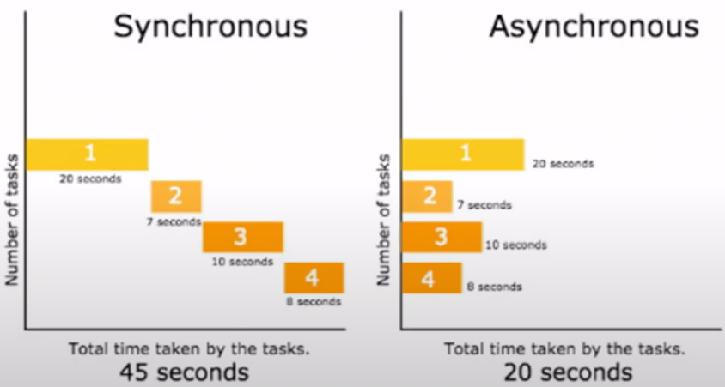

* **Key Components of LCEL:**

1. **StrOutputParser:**

* **Purpose:** Parses the output of a language model into a specific format, such as strings.
* **Usage:** Helps transform complex model outputs into structured data that can be further processed in subsequent steps. Suppose a model generates a response with unwanted metadata. **StrOutputParser** can clean this response, outputting only the text content.

1. **RunnablePassthrough:**

* **Purpose:** Directly passes the input through to the next step without any modification.
* **Usages:** Useful when you want to forward data or bypass certain steps in the workflow temporarily. If you need to pass raw data for logging without altering it, **RunnablePassthrough** acts as a simple pipeline placeholder.

1. **RunnableLambda:**

* **Purpose:** Allows custom functions (lambdas) to be executed within a chain.
* **Usages:** Use **RunnableLambda** to apply transformations, calculations, or custom logic within the workflow.

1. **RunnableParallel:**

* **Purpose:** Runs multiple tasks simultaneously in parallel.
* **Usages:** Ideal for scenarios where independent tasks (e.g., multiple API calls) can be executed concurrently. If you need to run sentiment analysis and keyword extraction simultaneously.

1. **Pipe (|) Operator:**

* **Purpose:** Concisely chain multiple operations, passing the output from one function as input to the next.
* **Usages:** Makes chain definitions compact and readable.

1. **Assign Method:**

* **Purpose:** Assigns the output of one function to a variable for reuse later in the chain.
* **Usages:** Allows you to store intermediate results and use them in subsequent steps.

1. **Asynchronous Invoke Method (ainvoke):**

* **Purpose:** Invokes a function asynchronously, enabling concurrent execution.
* **Usages:** Useful when working with I/O-bound tasks such as network requests or database access.

1. **Batch, abtach (asynchronous batch), stream, itemgetter:**

* **batch:** Processes multiple items in a single call, useful for handling batches of data.
* **abatch:** Asynchronous version of **batch** for concurrent batch processing.
* **stream:** Processes data in a streaming fashion, providing results as they are generated.
* **itemgetter:** Allows retrieving specific items from the output dictionary.

The **LangChain Expression Language (LCEL)** provides a powerful and flexible way to create sophisticated workflows in language model applications. Components like **StrOutputParser**, **RunnablePassthrough**, **RunnableLambda**, **RunnableParallel**, and operators like the **pipe (|)** and **assign** make it easy to chain tasks and process data in various ways, including **parallel** and **asynchronous** execution. This enhances the efficiency and modularity of workflows, making **LCEL** a valuable tool for building advanced applications.

**Memory in LangChain:**

* **Conversational ChatBot:**

A **conversational chatbot** is an AI-powered application designed to engage in a dialogue with users, simulating human-like conversation. Unlike rule-based or FAQ bots that respond with predefined answers, conversational chatbots are typically more dynamic and capable of understanding context and following multi-turn conversations. They often use natural language processing (NLP) to interpret user input, generate responses, and maintain an engaging and coherent conversation over time.

* **Does a Conversational Chatbot use Memory: Yes**, conversational chatbots often use a **memory** concept to maintain the flow and context of the conversation, especially over multiple turns. Memory allows the chatbot to remember details from earlier parts of the conversation, which it can use to provide relevant responses in later turns. Memory can range from simple short-term memory (remembering parts of the conversation within a single session) to long-term memory (recalling information across different sessions).
* **BaseChatMessageHistory:**

**BaseChatMessageHistory** is the foundational class for handling chat message history in LangChain. It defines the basic structure and interface for storing, retrieving, and managing conversation history between the user and the chatbot.

The foundational class defining the interface for managing chat message history, with methods for adding, retrieving, and clearing messages.

* **Purpose:**
* Acts as a **base class** from which other memory classes inherit.
* Establishes methods for **adding, retrieving, and clearing messages.**
* Ensures a consistent format for chat history.
* **InMemoryChatMessageHistory:**

**InMemoryChatMessageHistory** is a subclass of **BaseChatMessageHistory** that stores conversation history **in memory** (e.g., **using a list or similar data structure**). This means the data is kept in memory during the session but is lost once the session ends.

A subclass that temporarily stores chat history in memory, useful for single-session or short-term conversations.

* **Purpose:**
* Ideal for applications where **short-term memory** is needed and persisting data across sessions is not required.
* Suitable for **single-session interactions** where history doesn’t need to persist beyond the session.
* **RunnableWithMessageHistory:**

**RunnableWithMessageHistory** is a LangChain class used to create **runnable chains** that retain and manage conversation history. This class is particularly useful when creating a chain of processes (or tasks) that need to access past conversation data to provide contextually relevant responses.

Manages message history within runnable chains, useful in complex workflows that require context from past messages.

* **Purpose:**
* Allows chaining different operations (**e.g.,** summarization, translation) while maintaining access to conversation history.
* Supports **asynchronous** and **parallel execution**, which is helpful for handling multiple tasks at once.
* Useful in complex chatbot applications where multiple stages (e.g., context extraction, response generation) need access to conversation history.
* **Trim Message In Memory:**

**Trim Message in Memory** is a technique used to **limit the size of conversation history** in memory. As conversations grow longer, storing all previous messages can become inefficient and may exceed model input limits.

Limits the memory history to a fixed number of recent messages, ensuring efficiency and staying within token limits.

* **Purpose:**
* **Prevents memory overload** by keeping only the most recent messages.
* Ensures the chatbot operates within **token limits** (e.g., the maximum number of tokens a language model can process).
* Improves **processing speed** by reducing the history size.
* **Conversational Buffer Memory:**

**Conversational Buffer Memory** stores the **entire conversation history** as a single buffer, allowing the chatbot to access all previous interactions with the user. It’s useful for retaining full context, but it can become memory-intensive over long conversations.

* **Example:**

Consider a chatbot that assists with customer support. With Conversational Buffer Memory, the bot remembers everything from the session, allowing it to refer back to previous messages without losing any context.

* **Pros:**
* **Complete context**: Remembers the full conversation, providing comprehensive context.
* **Useful for complex conversations**: Ideal for scenarios where every part of the conversation might be relevant.
* **Cons:**
* **Memory intensive**: Storing the entire conversation can be costly in terms of memory, especially in long interactions.
* **Exceeds token limits**: Large conversation histories may hit token limits, causing issues in models with limited input size.
* **Conversational Buffer Window Memory:**

**Conversational Buffer Window Memory** retains only the **most recent messages** within a specified window size, discarding older messages as new ones are added. This memory type helps maintain some context without overloading memory.

* **Example:**

Imagine a chatbot where only the last three messages are relevant for follow-up questions. Conversational Buffer Window Memory stores only these recent exchanges.

* **Pros:**
* **Memory efficient**: Limits memory usage by keeping only the most recent exchanges.
* **Avoids token overflow**: Prevents reaching token limits by restricting the conversation history length.
* **Cons:**
* **Limited context**: Older messages are discarded, which may lead to a loss of useful context.
* **Not suitable for complex interactions**: For complex conversations requiring full context, this memory type may be insufficient.
* **Conversational Summary Memory:**

**Conversational Summary Memory** summarizes the conversation instead of storing it in full, reducing memory usage while preserving essential information. This type is ideal for long conversations where a summary can capture the gist.

* **Example:**

A customer support bot could summarize interactions periodically, such as summarizing an initial discussion about account setup and issues raised, without retaining all messages verbatim.

* **Pros:**
* **Memory efficient**: Summarization reduces memory usage significantly.
* **Maintains key context**: Retains essential points without storing all messages.
* **Cons:**
* **Potential loss of detail**: Summarization may miss nuances or finer details of the conversation.
* **Reliant on summarization quality**: The quality of the memory depends on the quality of the summarization model.
* **Conversational Summary Buffer Memory:**

**Conversational Summary Buffer Memory** combines **summary and buffer memory** by keeping a summary of earlier conversation segments while retaining the recent exchanges in full. This hybrid approach balances context preservation with memory efficiency.

* **Example:**

A chatbot that summarizes older parts of the conversation but keeps recent interactions fully accessible is a good use case. This way, the bot has immediate access to recent exchanges and can refer to earlier summaries when needed.

* **Pros:**
* **Efficient balance**: Combines detailed recent context with a summarized past, balancing memory and detail.
* **Useful for extended interactions**: Works well for long conversations by summarizing older parts.
* **Cons:**
* **Higher complexity**: Requires managing both summary and buffer, increasing complexity.
* **Potential context loss in summaries**: Important details might be missed or overly condensed in the summary.
* **Conversational Entity Memory:**

**Conversational Entity Memory** tracks specific **entities** (such as names, dates, locations, or topics) mentioned throughout the conversation. This allows the chatbot to remember and reference these entities across different turns without retaining entire messages.

* **Example:**

Imagine a chatbot that tracks entities like the user’s name, location, or preferences mentioned during the conversation. If a user says, "My name is John, and I live in New York," the bot stores “John” as the name and “New York” as the location.

* **Pros:**
* **Efficient entity tracking**: Stores key information (e.g., name, preferences) without retaining full conversation history.
* **Useful for personalization**: Enables personalized responses by recalling user-specific details.
* **Cons:**
* **Limited scope**: Only stores specific entities, lacking broader conversational context.
* **Requires entity extraction**: Relies on accurate entity extraction to function effectively.
* **Comparison between Memories:**

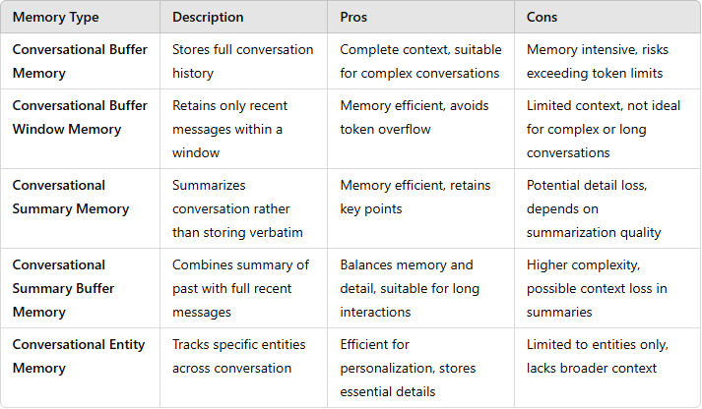

* **When to use which Memory:**
* **Decision-Making Guide:** To decide on the best memory type for your chatbot, consider the following questions:

1. **How long are the Conversations?**

* **Short:** Buffer Window Memory.
* **Long:** Summary or Summary Buffer Memory.

1. **Is complete context important?**

* **Yes:** Buffer Memory.
* **No:** Buffer Window or Summary Memory.

1. **Are there memory or token constraints?**

* **Yes:** Summary or Entity Memory.
* **No:** Buffer or Summary Buffer Memory.

1. **Is personalization required?**

* **Yes:** Entity Memory.
* **No:** Buffer, Summary, or Summary Buffer Memory.
* **Comparison:**

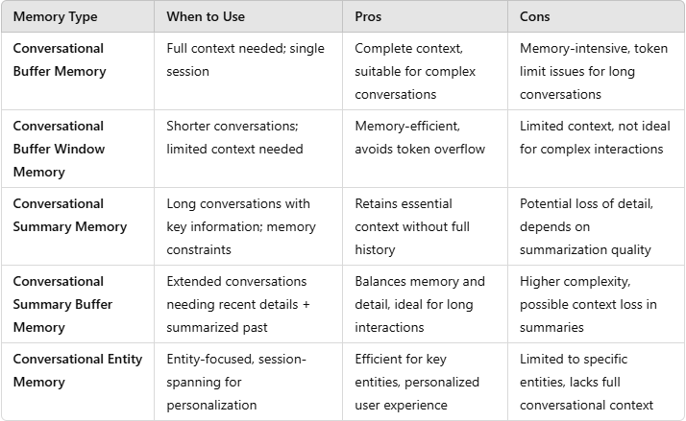

**Agent:**

**LangGraph:**